# Friends Families and Travellers Style and Content Guide

## Basic rules about adding content and formatting content.

### Content

* **Write relevant content**  
  It may be tempting to write about your brother's dog, but if it doesn't relate to your site or page topic, leave it out. Web readers want information, and unless the page is information about said dog, they really won't care, even if it is a good metaphor for what you're trying to say.
* **Put conclusions at the beginning**  
  Think of an inverted pyramid when you write. Get to the point in the first paragraph, then expand upon it.
* **Write only one idea per paragraph**  
  Web pages need to be concise and to-the-point. People don't read Web pages, they scan them, so having short, meaty paragraphs is better than long rambling ones.
* **Use action words**  
  Tell your readers what to do. Avoid the passive voice. Keep the flow of your pages moving.

### Format

* **Use lists instead of paragraphs**  
  Lists are easier to scan than paragraphs, especially if you keep them short.
* **Limit list items to 7 words**  
  Studies have shown that people can only reliably remember 7-10 things at a time. By keeping your list items short, it helps your readers remember them.
* **Write short sentences**  
  Sentences should be as concise as you can make them. Use only the words you need to get the essential information across.
* **Include internal sub-headings**  
  Sub-headings make the text more scannable. Your readers will move to the section of the document that is most useful for them, and internal cues make it easier for them to do this (see below).
* **Make your links part of the copy**  
  Links are another way Web readers scan pages. They stand out from normal text, and provide more cues as to what the page is about.

## How content should be laid out on pages

On modern websites the styles are completely separate from the content.

The style of the page includes the fonts used, the colours of the fonts and any spacing between paragraphs.

WordPress has a semi wysiwyg (what you see is what you get) editor which looks similar to work. The content you add to a page will not look exactly the same as when you look at it in a browser.

For example, the image below shows the picture in a different place to viewing it on a website.

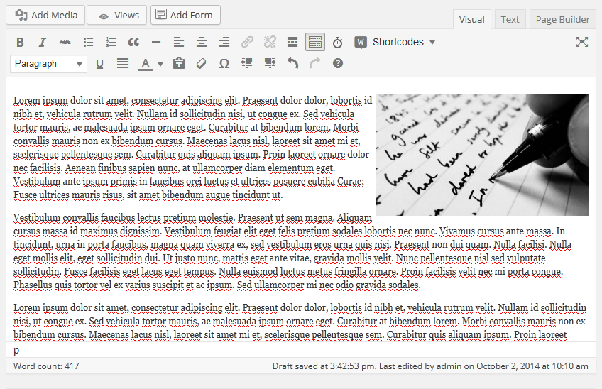

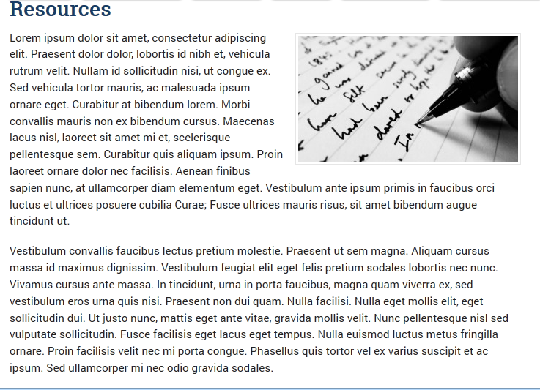

When it is viewed on a mobile phone the image will be in a different place again.

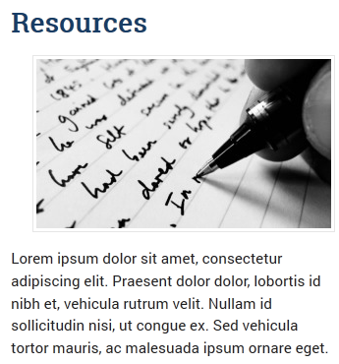

This means that you do not have to get the content looking perfect in the editor, its more important to press the preview button and look at the content in a webpage.

This is most often a problem when adding images.

## Headings and sub-headings

Think of content like a book. The name of the website is title of the book, each page is a chapter and the chapter can be split into sub-sections.

On websites we use headings to split the content into sections. This is important because it makes the content easier to read and search engines index content by looking for headings. Headings are considered to be more important.

When writing in Word we quite often use bold for a heading, unfortunately, search engines will read this as bold text and not a heading.

Headings can be accessed through the editor menu. Usually the text says paragraph.

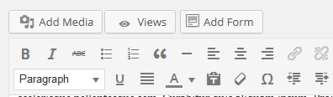

On the FFT website the page title is always heading 1, this means that heading 1 should not be used in the content (you can’t have a chapter within a chapter). All sub-headings are heading 2.

Heading 3 can be used, but this must be within heading 2.

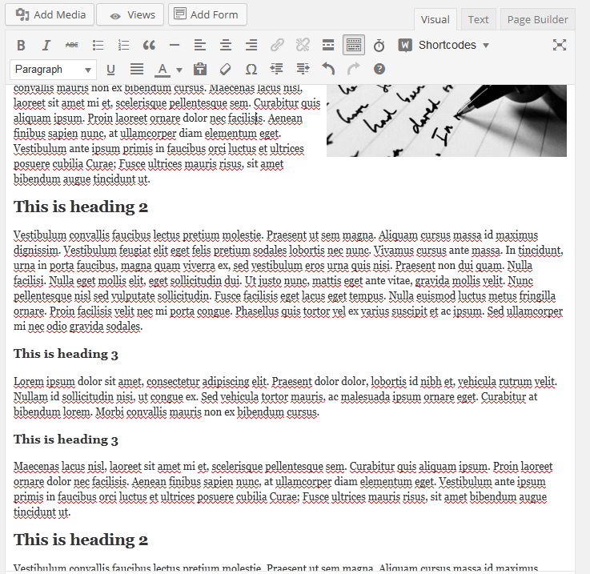

## Guidelines for adding content

Think about how the content will look for the audience. Some suggested rules are:

* Use headings to break up the text – it is difficult to read huge chunks of dense text.
* Use bold if you want to add emphasise some content.
* Use short sentences and lots of paragraphs.
* Photos and images can communicate better that words, and can make the content look interesting.
* Only use one level of bullets or numbers. WordPress does not cope with lists within lists and the content may end up looking confusing.
* Never use underline unless it’s a link.
* Think about how much text there is on a page – people don’t want to read too much.
* Consider “hiding” large chunks of text with accordions.
* ALL UPPERCASE can be difficult to read.
* Boxes can be used to draw the attention of the user to actions (for example how to get in touch).

## Adding links

Internal and external links read the read from the content on the page to other relevant content.

Sometimes you might want to lead people to a sub-page or you might want to link people to a different websites.

Links are really easy to add, but think about the text you are using to create the link. It should ideally describe the content you are linking to.

For example, you can say, “find out more about the Romany history of the BBC website.” Or “read more about pregnancy and child birth”.

Try to make the linked text relatively long, so people have chance to see the link.

Try not to use “click here” or even click “here” although sometimes it’s really difficult to think of anything better.

## Site structure: parents, children and grandchildren

All the pages that are linked to the main menu are known as parent pages.

Usually parent pages should be a summary of the content linked to this page and are known as landing pages. This means that each landing page should not have too much text.

The main content of the website is on the level below parent pages and are known are child pages.

Each child page has a parent. You can see these in the sub-menu on the left hand side.

The pages on the level below child pages are known as grandchild pages or third level pages. You can only see these on the sub-menu if you are on the correct page.

Grandchild page content should be directly related to the child paged.

On the fft website:

* Your family – parent page
* health – child page
* Having a baby – grandchild page (because its related to health)

## Adding images

I think WordPress is easy to use, unfortunately, adding images are slightly complex. The editor guide shows exactly how to add images to pages.

Here are some guidelines about adding images:

* ALWAYS MAKE SURE THAT YOU HAVE PERMISSION TO USE THE IMAGE (sorry to use uppercase). You may not have permission to use images from websites and could end up being sued.
* Resize the images before uploading them to the page. A full width image should be around 710px wide and a small image 300px wide.
* Try not to make images too large. An image which is 700px by 700px will take over the page.
* Text on images is not text. For example a poster containing a fair amount of text is not readable on mobile phones or by search engines. If you need to add a poster, consider adding the text separately.
* Use a proper title or separate alt tag. You can also use a caption.
* Make sure the image complements the content of the page (a photo of kittens on a page about barges is not going to communicate).
* You can make images smaller but not bigger (jpeg photos are compressed to trying to make a small image larger means you lose details).
* You only need to upload each image once. It is stored in the media library. If an image is too large or in the wrong page, delete is and add it again from the media library.

It may be a good idea to have a stock of images that you can add to pages.

## Audiences

The website is split into two sections for two different audiences. In addition news is information for both audiences (but probably should be directly more towards service users).

Items pages that are linked from the main menu (home, your family, your health etc) are aimed at service users. Content should be written with service users in mind.

Pages linked from the top menu (about, what we do etc) are aimed at students, professionals and funders although service users may read this content.

The same rules apply to both audiences, but it’s more important to make sure service user content is even clearer.

## Service user content vs other content

Service users:

* Be less use to reading on the web so their content must be clear, to the point and visually engaging.
* May have literacy problems so you need to think about the amount of text, how it is laid out on the page and the language used.
* Will want to find their and content quickly so they may want content that is straight to the point and clear.
* Are more likely to be using mobile devices, so you need to think about how the content will look on a small screen and whether any downloads are accessible.
* May be engaged with content more if there is an accompanying image.
* Think about how service users may be feeling and make sure the content is suitable (for example they may have a crisis and are looking for help)

Other content:

* Content for other audiences can be longer and contain more complex language.
* There can be attachments to pages since they are quite likely to be using a computer or a tablet.

## When to add content

If you want to add something to the site think about the following:

* Who it is for – service users or other audiences and add it to the correct section.
* Whether it is useful – if you add to much content to a site the useful content may be hidden.
* Whether it is up to day or how long it will remain relevant.
* Whether its already on the site (use search or search within pages).

Try to make each section of the site easy to navigate. If you have too many sub-pages they might be difficult to find.